Lab 9 – PHP and MySQL

# Purpose

* Explore MySQL using PHP
* Upload your website to a Web server

# Due Date

* This lab must be handed in:

**Sunday, Nov 25-2018 – before midnight**

# Assessment

* This Lab is worth 2% of your total course mark.

# Assigned Readings

The following chapters of ‘Fundamentals of Web Development’ will be useful in completing this exercise:

* Chapter 11

# Lab Supplies

To complete this lab you will require the following lab supplies:

* Textbook: Fundamentals of Web Development
* EasyPHP, or other WAMP server
* Eclipse, Notepad (or other text editor, or IDE)
* FileZilla (or other FTP client)

# Summary of Tasks

1. Gather MySQL Information
2. Understanding your database
3. Develop the logic to display your web application
4. Upload your website to the webserver
5. View your webpage using a web browser
6. **Submit Lab Link on Brightspace**
7. **Submit Source Code of all PHP files on Brightspace**

# Task 1

Before we can get started using MySQL on the webserver we need a few pieces of information.

* Host
  + The host variable should contain the value “localhost”.
  + Example: $host = “localhost”;
  + NOTE: Localhost is a networking term meaning ‘this computer’
* Username
  + The Username to access YOUR database is to be structured as follows:
  + Example: $username = “<your-username>_Lab9”;
* Password
  + The password is any legitimate password you choose
* Database Name
  + The name of your database is to be structured as follows:
  + Example: $database = “<your-username>_Lab9”

# Task 2

To create your database, username, password and tables on the Hebergement Web server, please review the following document on Brightspace:

Course Content -> Module 5 – Advanced Web Programming -> Part 2- PHP and MySQL -> PHP, MySQL CRUD Example-Hebergement.zip -> Instruction_MySQL_Hebergement.docx

# Task 3

Now that we have a database we have to understand the tables inside it. Your database must contain a table named *Employee*:

The ‘*Employee*’ table has the following columns.

* EmployeeId, INT, Primary Key, NOT NULL, AUTO INCREMENT
* FirstName, VARCHAR(50), NULL
* LastName, VARCHAR(50), NULL
* EmailAddress, VARCHAR(255), NULL
* TelephoneNumber, VARCHAR(20), NULL
* SocialInsuranceNumber, VARCHAR(11), NULL
* Password, VARCHAR(50), NULL
* Designation, VARCHAR(50), NULL
* AdminCode, INT, NULL

**NOTE: *EmployeeId*** is listed as ‘AUTO INCREMENT’ meaning that the database will automatically populate this field.

Before getting started with the following tasks, review the ‘Common Look and Feel’ video provided on Brightspace (under: Course Content 🡪 Extra Materials). Using the knowledge gained in these materials, implement the following Design Pattern to create a ‘Common Look and Feel’ to be used on every page of your website.

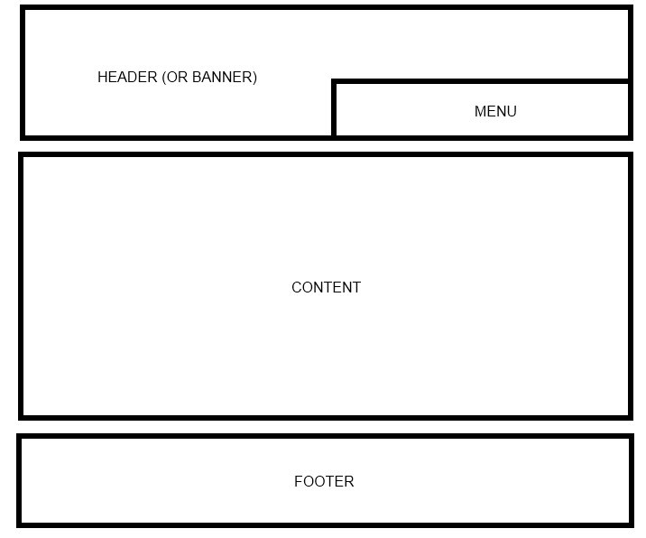

Your web site will include the following PHP scripts:

* Header.php
* Footer.php
* Menu.php
* CreateAccount.php
* Login.php
* ViewAllEmployees.php
* Admin.php
* SelectAccount.php
* UpdateAccount.php
* UpdateComplete.php

**NOTE:** CreateAccount.php, Login.php, ViewAllEmployees.php, Admin.php, SelectAccount.php, UpdateAccount.php, and UpdateComplete.php must include the Common look and feel implemented in Header.php, Footer.php and Menu.php.

**Header.php**

Header.php must contain a script to display a Common Header that will appear on every page. The header must contain a banner (images, css, etc).

**Footer.php**

Footer.php must contain a script to display a Common Footer that will appear on every page. The footer must contain Student Number, First Name, Last Name, and Email Address

**Menu.php**

Menu.php must contain a script to display a Common Menu to be shown on every page. The menu must contain links to ***CreateAccount.php***, ***Login.php***, ***ViewAllEmployees.php***, and ***SelectAccount.php***

**NOTE**: ***Admin.php***, ***UpdateAccount.php***, and ***UpdateComplete.php*** should be accessed by clicking on the link for ***SelectAccount.php.***

**CreateAccount.php**

Create a form that will create employee accounts in the ‘Employee’ table of your database.

Details:

1. Use ‘input’ tags to accept the information listed in Task 3. Your form must populate all the columns of the ‘Employee’ table to create an employee account.
2. Using the above form, you have to create two types of employee account (i) ITDeveloper, and (ii) Manager. While creating an ‘ITDeveloper’ account, Admin Code may be set as ‘111’ (Designation = ’ITDeveloper’, Admin Code = 111). Again, while creating a ‘Manager’ account, it is MANDATORY to set the Admin Code as ‘999’ (Designation = ’Manager’, Admin Code = 999). You need to create at least three **ITDeveloper** accounts and one **Manager** account.
3. After the information has been submitted to the database, save each of the values from the form in the Session State.
4. Once the employee data is stored in the Session, automatically redirect the user to ‘**ViewAllEmployees.php**’

**NOTE**: Session_StoreValues.php (posted on Brightspace) has an example of programmatically sending an employee information to another page in your website.

Sample Screenshot for ***CreateAccount.php*** is as follows:

|  |
| --- |
|  |

**Login.php**

The form ***Login.php*** allows the user to log into your application.

Details:

1. Create a form to accept the employee’s EmailAddress and Password as credentials to your site. Use an SQL Query to determine if the person has an account.
2. If the user has an account, store ALL of their personal information in the Session State and then redirect the user to ‘ViewAllEmployees.php’. Display an error if the user cannot log into the system.

Sample Screenshot for ***Login.php*** is as follows:

|  |
| --- |
|  |

**ViewAllEmployees.php**

This page pulls information from both the Session and the Database and displays the information to the user.

Details:

1. If the employee tries to navigate to this page without having logged in – the employee should be redirected to the login page.
2. If the employee has successfully logged into the application and is directed to the page, then display the following information
   1. Divide the content of the page into 2 sections (One on top of the other)
   2. The top section of the page will display all details of the employee stored in the Session State
   3. The bottom section of the page will display a HTML table containing all rows and columns of the ‘Employee’ table of your database**.** The HTML table must also contain a header row that identifies the column name of the database table.
   4. Provide H1 HTML headers so that both sections (Session State Data and Database Data) are clearly marked

**NOTE**: To verify that an employee has successfully logged in, check for valid information in the Session State. If the Session State does not contain valid information redirect to the login page, otherwise, the user has logged in successfully.

Sample Screenshot for ***ViewAllEmployees.php*** is as follows:

|  |
| --- |
|  |

**Note**: You do NOT need to display the values of ‘Password’ and ‘AdminCode’ fields of the ‘Employee’ table**.**

**SelectAccount.php**

The form **SelectAccount.php** allows the Manager to select an employee whose information (that is previously stored into Employee table) needs to be updated.

Details:

1. If anyone tries to navigate to this page, the person should be redirected to the **Admin.php** page. Create a form to accept the employee’s EmailAddress, Password and Admin Code as credentials to your site. Only the Manager (Admin Code =999) will be able to access this page. Use an SQL Query to determine if the person has an account and he is a Manager.

Sample Screenshot for ***Admin.php*** is as follows:

|  |
| --- |
|  |

1. If the Manager has successfully logged into the application, he/she will be directed to the ***SelectAccount.php*** page that will display the following form to select an employee whose information needs to be updated:

|  |
| --- |
|  |

1. After clicking on the ‘Edit Employee’ button, the Manager should be redirected to the form ***UpdateAccount.php*** which allows the user to update the information of the corresponding employee.

Sample Screenshot for ***UpdateAccount.php*** is as follows:

|  |
| --- |
|  |

1. After clicking on the ‘Update Record’ button, the modified information of the corresponding employee should be updated into the Employee table of the database and a success/error message will be displayed in ***UpdateComplete.php***.

Sample Screenshot for ***UpdateComplete.php*** is as follows:

|  |
| --- |
|  |

**NOTE**: All the sample screenshots must include common header, footer and menu files.

**NOTE**: The Brightspace file ‘PHP, MySQL CRUD Example-Hebergement.zip’ contains a detailed example of the things you are expected to do in this lab.

# Task 5

Upload your website to the Web server. Use an FTP client to connect to your Web server.

Once you connect to the webserver using an FTP client, create a directory called ‘/CST8238/Lab9’. Once your course directory has been created navigate to that new directory. Add your PHP files to this location.

We recommend the FTP client FileZilla. The program is provided for free (and open source for those who are interested in such things) by the Mozilla Foundation; the makers of Firefox and Thunderbird.

# Task 6

View your website using a web browser. Open a web browser and navigate to the following web address:

**http://web-server_domain_name/CST8238/Lab9/<filename>**

For example, the web address to my page is:   
  
<http://profrejaul.com/CST8238/Lab9/CreateAccount.php>

Where ‘profrejaul.com’ is the domain name of the Web server, ‘ /CST8238/Lab9’ is the name of the directory I created in the Web server using FTP client and ‘CreateAccount.php’ is the home page for this lab.

# Task 7

Once you have confirmed that your webpage is available online, you are ready to hand in your lab.

Create a compressed file (**Lab9.zip**) which will contain the following PHP files:

* Header.php
* Footer.php
* Menu.php
* CreateAccount.php
* Login.php
* ViewAllEmployees.php
* Admin.php
* SelectAccount.php
* UpdateAccount.php
* UpdateComplete.php

Create a word document (**Lab9.doc**) in which write the following Information:

* Student Number
* First Name
* Last Name
* The URL, or hyperlink of the home page (CreateAccount.php) of Lab 9

To hand in your lab go to Brightspace and navigate to Content 🡪 Labs and click on ‘Lab 9 – PHP and MySQL’ link.

Upload the word document (**Lab9.doc**) and the compressed file **(Lab9.zip**) on Brightspace.

Finally, click the ‘Submit’ button to send the lab to your professor.

N.B. Please keep in mind that ONLY .**zip** file is accepted as the format of the compressed file.

**IMPORTANT NOTE**:

If the URL, or hyperlink, does not direct the professor to the lab you will receive a ZERO for the lab assignment.

**IMPORTANT NOTE:**

You may only submit a Lab ONE TIME. Be sure the lab is complete before clicking on the ‘Submit’ button.